

INFLO UX Evaluation Plan & Documentation

1600 International Drive

McLean, VA 22044

P: (571) 423-0200 F: (703) 880-0196

**www.octoconsulting.com**

INFLO UX Evaluation Plan Overview

Although a hackathon environment provides constraints around direct engagement with real users, many UX activities can still be applied to measure and optimize the user experience, as well as begin the planning of future activities to provide comprehensive evaluation and alignment of INFLO to user needs. The following evaluation plan details activities to convey what methods of evaluation have already been applied to INFLO, and which activities could be applied during future releases in order to deliver an elite user experience.

Table of Contents

**INFLO Evaluation Plan Overview2**

**Initial Discovery Methods5**

**Persona Development5**

Persona Creation Process7

INFLO Persona Development Worksheets7

INFLO Personas7

INFLO Workflows7

**Heuristic Evaluation6**

Heuristic Evaluation Overview7

Heuristic Evaluation Process7

INFLO Heuristic Evaluation7

**UX Testing Plan9**

UX Testing Creation Process

UX Testing Approach

INFLO UX Testing Plan

INFLO UX Test Scripts

**Future Evaluation Resources8**

Interviews

Analytics

SMEs

Other Resources

**Initial Discovery Methods**

Provided with a longer evaluation period, Octo would bring the following resources to bear in fully evaluating INFLO’s performance against user needs. To discover scope and initial user requirements, Octo engages early in the process to rapidly determine user needs, pain points, desired functionality and available content. Below are sample questions typically asked in these engagements, and applied to INFLO

Individual interviews resemble focus groups because they involve talking with users but they differ in the amount and quality of data that can be gathered. In individual user interviews you:

* Talk to just one or two person(s) at a time
* Have more time to discuss topics in detail
* Do not have to worry about the “group dynamics” that tend to occur in focus groups
* Can give the interviewee your full attention and adjust your interviewing style

**Analytics**

Analytics give basic insight into users and product performance. This data can help in the analysis of more complex user activity and help get a deeper understanding of everything users do while interacting with a web site.

**SMEs**

SMEs provide positive impact on engagements and the development of usability testing. Monopolizing on the SMEs' knowledge of the subject matter, they are valuable resources when developing test criteria.

**Other Resources**

Other resources can include items or methods such as:

* Task Analysis
* Card Sorting Sessions
* Process or Workflow diagrams
* User Personas
* User Journey Maps
* User Empathy Maps

Although not directly applicable to this instance of INFLO implementation, the above resources will provide a more complete an accurate picture of user performance on INFLO, potential future release features, and pain points being experienced by users, informing future iterations of the product and its broader implementation strategy.

**User & Project Interview Questions**

**Project Vision**

* What is the vision for this offering?
* What defines success for this project?
* What are the potential pitfalls?

**Users**

* Different types of users?
* Who is primary?
* Role(s)?
* Typical Background?
* Defining Attribute?
* Target user(s)?
* What problem do they have that the product solves?

**User Goals**

* What defines success for the user?
* What is a bad result? (If an experience doesn’t go well, what happens?)
* If users had a “magic wand” and could wish for anything to make the process better, what would they wish for?

**Value Proposition**

* What problems do users have that this offering solves?
* What is the core value proposition of the offering?
* What are the main messages?

**Competition/Other Options**

* What similar/current tools are in use today?
* Target audience? Value proposition?
* What are the relative strengths/weaknesses?
* How is this offering different?

**Process & Workflow**

* What is the nature of the user and their tasks/objectives?
* How do they prepare?
* Who do they work with?
* What tools do they use?
* How do they engage?
* What is the first step?
* And the next (and so on)?
* How does the engagement end?
* What frustrations/ pain points do they experience with their current process?

**Context of Use**

* What tools do the users use today?
* Where do those tools fit? (collect screenshots, printouts, any relevant items if possible)
* What data points do they collect today?
* What intelligence are they able to share with the chain of command/managers/etc. currently?
* How do they share it?
* What does it look like?
* What’s missing in the current process that this product will provide?
* Where do you imagine your new (or redesigned) product will fit?

**Persona Development**

The goal of introducing and building personas is to define the mindset, desires, and daily tasks of system users. UX Analysts inform the persona creation process by conducting research, user interviews and surveys, which help reinforce the proposed personas.

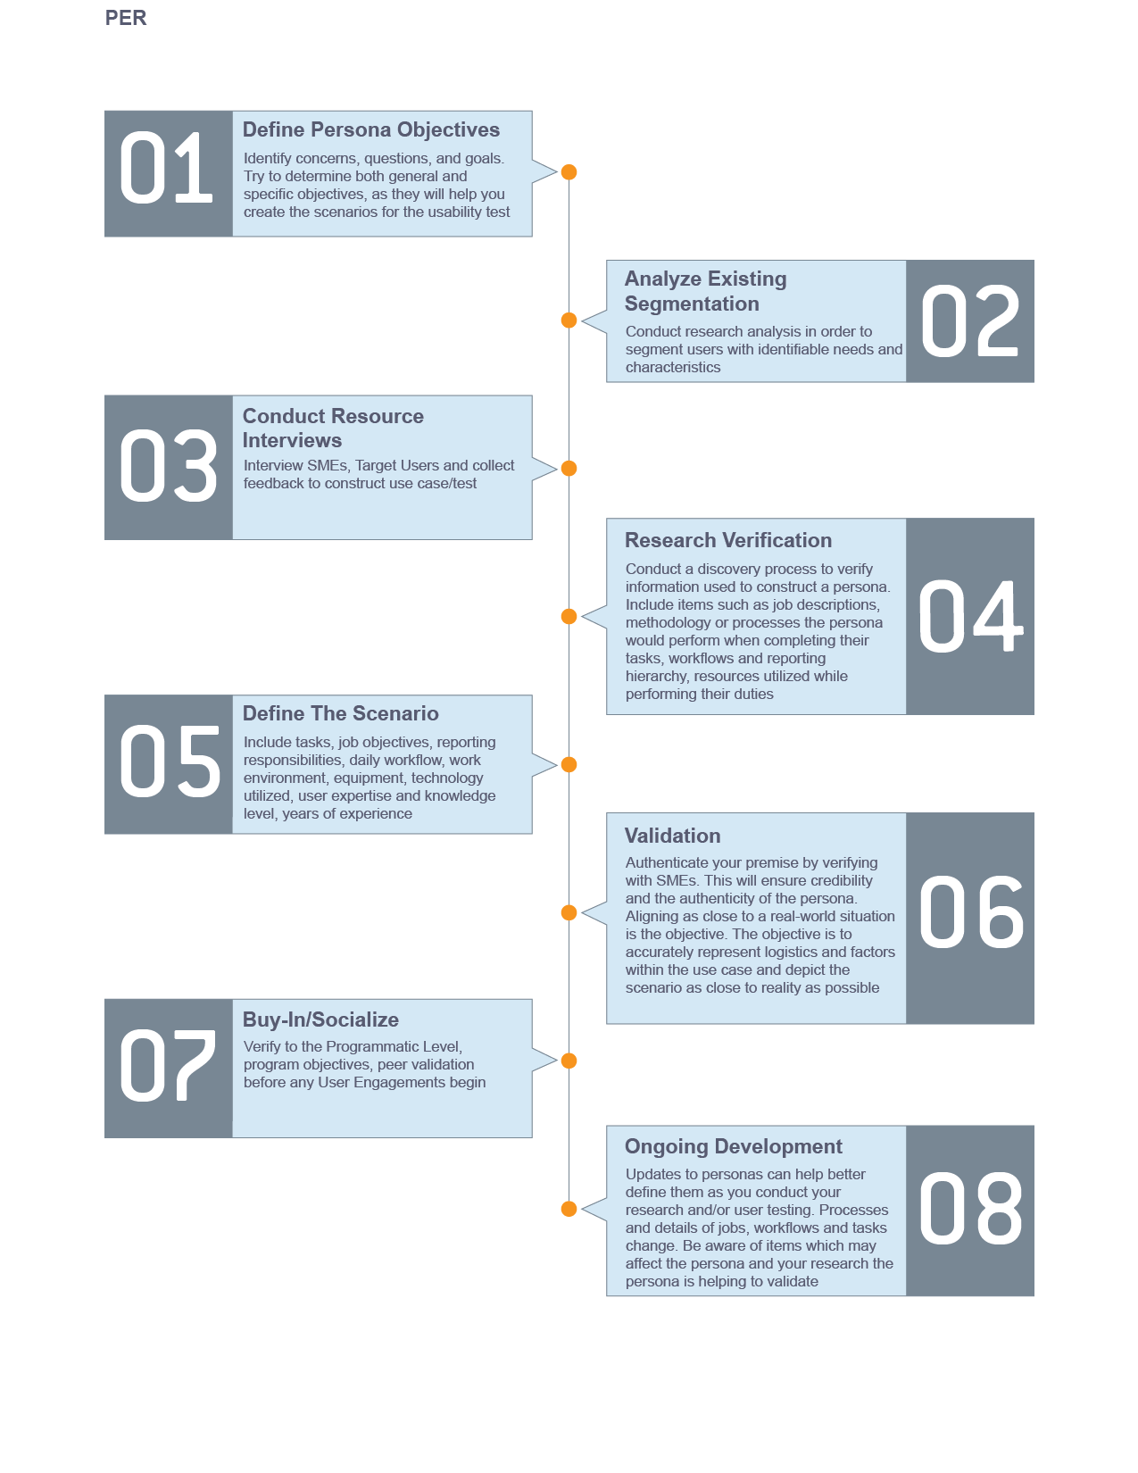**Persona Creation Process**

**INFLO Persona Development Worksheet Example**

|  |  |
| --- | --- |
| **Persona Development Worksheet** | |
| **1. Persona Title**  What kind of persona are you developing? Usually is a title or category | Home Buyer/Owner |
| **2. Specific Persona Details**  Give specific details to add personality to your persona. This isn’t always necessary but can add credibility to your research. | Beth is a 35 year old woman interested in buying a new home. She wants to make an informed decision about her purchase, including information about the surrounding area. Beth wants to purchase a home that is livable according to her criteria, as well as in an area that will provide a strong long-term investment |
| **Agency Researcher lowing evaluation methods can also be brought to bear to more fully surface user needs and3. Mission**  Give specific examples of the persona’s taskings, daily responsibilities, daily objectives, etc. Be as detailed as possible. Source job descriptions, interview real people who fit the profile and/or SMEs. | Beth wants to buy a home based on several criteria. Since she wants to live in a well-developed area, but also one that is environmentally safe.   * View travel safety information * View air & water quality information * View Demographic information |
| **4. Technology Skill Level**  This is an overview of the user’s skill level with the technology they use to complete their objectives, tasks and perform their job duties. | This user is very comfortable using web technologies, and has high bandwidth access, allowing for an unimpeded browsing experience. This user is likely to use either mobile or desktop devices to access the product. |
| **5. Tools**  This is a listing of the tools the persona uses daily to perform their job duties. | Internet Explorer, Google Chrome, Mozilla Firefox, Opera |

**INFLO Personas**

**Heuristic Evaluation Overview**

Heuristic evaluation is an assessment method, which rates software applications and interfaces based on compliance with basic human factors principles of design. For any evaluation, identify initial concerns and the specific focus of the assessment. Determine both general and specific objectives and whether it is a major, moderate or minor undertaking.

**Example Evaluation Criteria:**

* Perceiving and Evaluating the System
* Developing and Executing Action Sequences
* Context and Relations
* Specific Interface and System Issues

Any system should be designed in a way that maximizes the ease with which information can be assimilated, while minimizing the effort required determining what is occurring in the system.

Factors that contribute to the user’s perception and evaluation of a system are listed above, and a product’s adherence to them is measured by multiple UX expert evaluators, to ensure that outlying opinions are mitigated, and the evaluation is rigorous, and deeply explores functionality.

**Heuristic Evaluation Process**

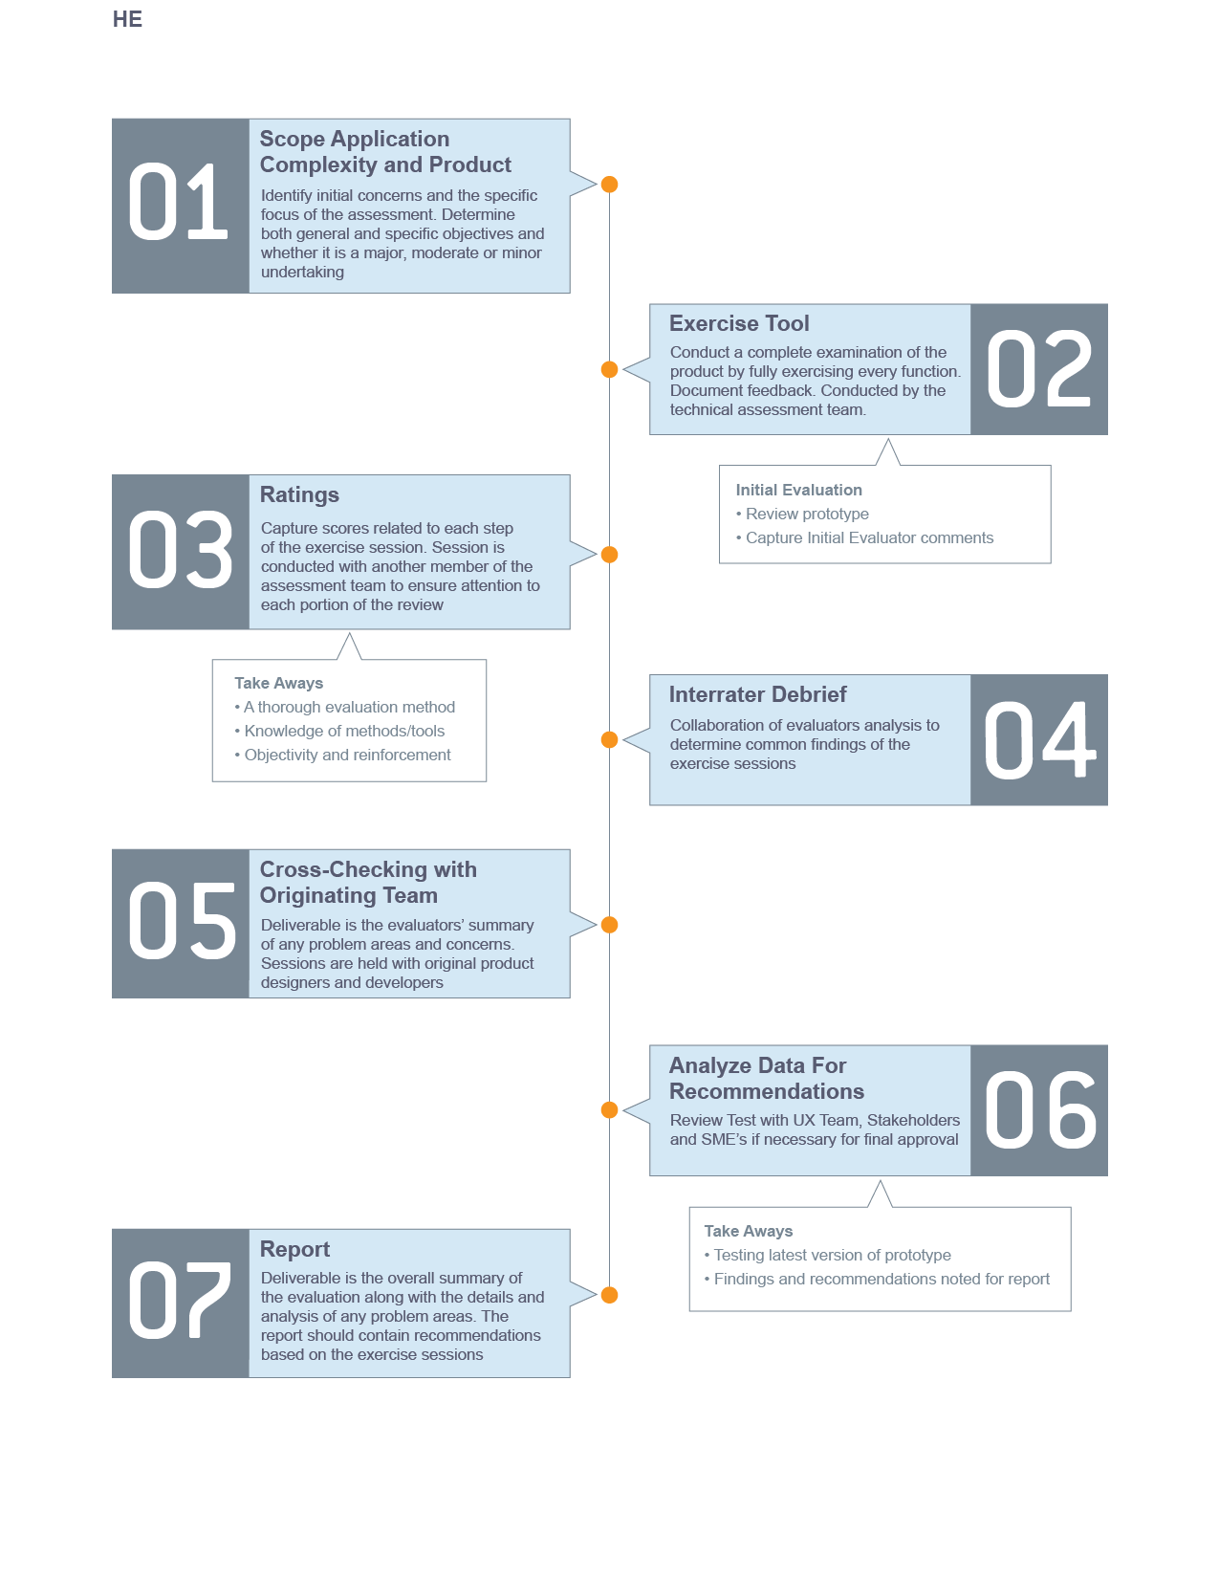

**INFLO Heuristic Evaluation**

**Summary**

The Second Mockathon UX team was tasked to perform an evaluation of the “INFLO” website on 21 March 2015. This report summarizes the high level findings of this evaluation.

Two primary concerns were exposed. Complicated language was used throughout the application that would confuse the user and discourage use. A lack of simplified instruction was not available creating a unclear landing page. Detailed descriptions of all usability issues exposed during this evaluation are included in the following sections.

**Assessment Method**

Heuristic evaluation is an assessment method which rates software applications and interfaces based on compliance with basic human factors principles of design. For this evaluation, four areas were considered.

1. Perceiving and Evaluating the System
2. Developing and Executing Action Sequences
3. Context and Relations
4. Specific Interface and System Issues

**Overall Impressions**

From the INFLO homepage, users can easily search for a county to view comparative data from. However no information on what data will be retrieved is available. There is no example data available and no description of the pages purpose. The page focus should be set on the input box on page load.

The INFLO dashboard shows the county and associated state that was searched for. It gives an overall score that is not self-explanatory. The score percentage should be in comparison to all other counties to show context. Four tiles showing Water Quality, Air Quality, People, and Travel Safety are showing county data. This data does not provide context and displays a percentage that is not associated with a positive or negative result. Results should show percentages lower or higher than all counties data.

**INFLO Home Screen (Wireframe):**

* Logo centered at top (alt text for logo image)
* Search centered under logo (alt text for search button if image used)
* Search includes example input “Fairfax, VA”
* Focus is on search on page load
* Tagline below search box
  + “How much do you know about where you live?”
* Search informative infographic
  + “Search for a County” “View the Score” “Explore the Details”
  + Three screenshots showing steps. (alt text explaining images)
  + Arrows showing flow. (alt text “Arrow pointing right”)

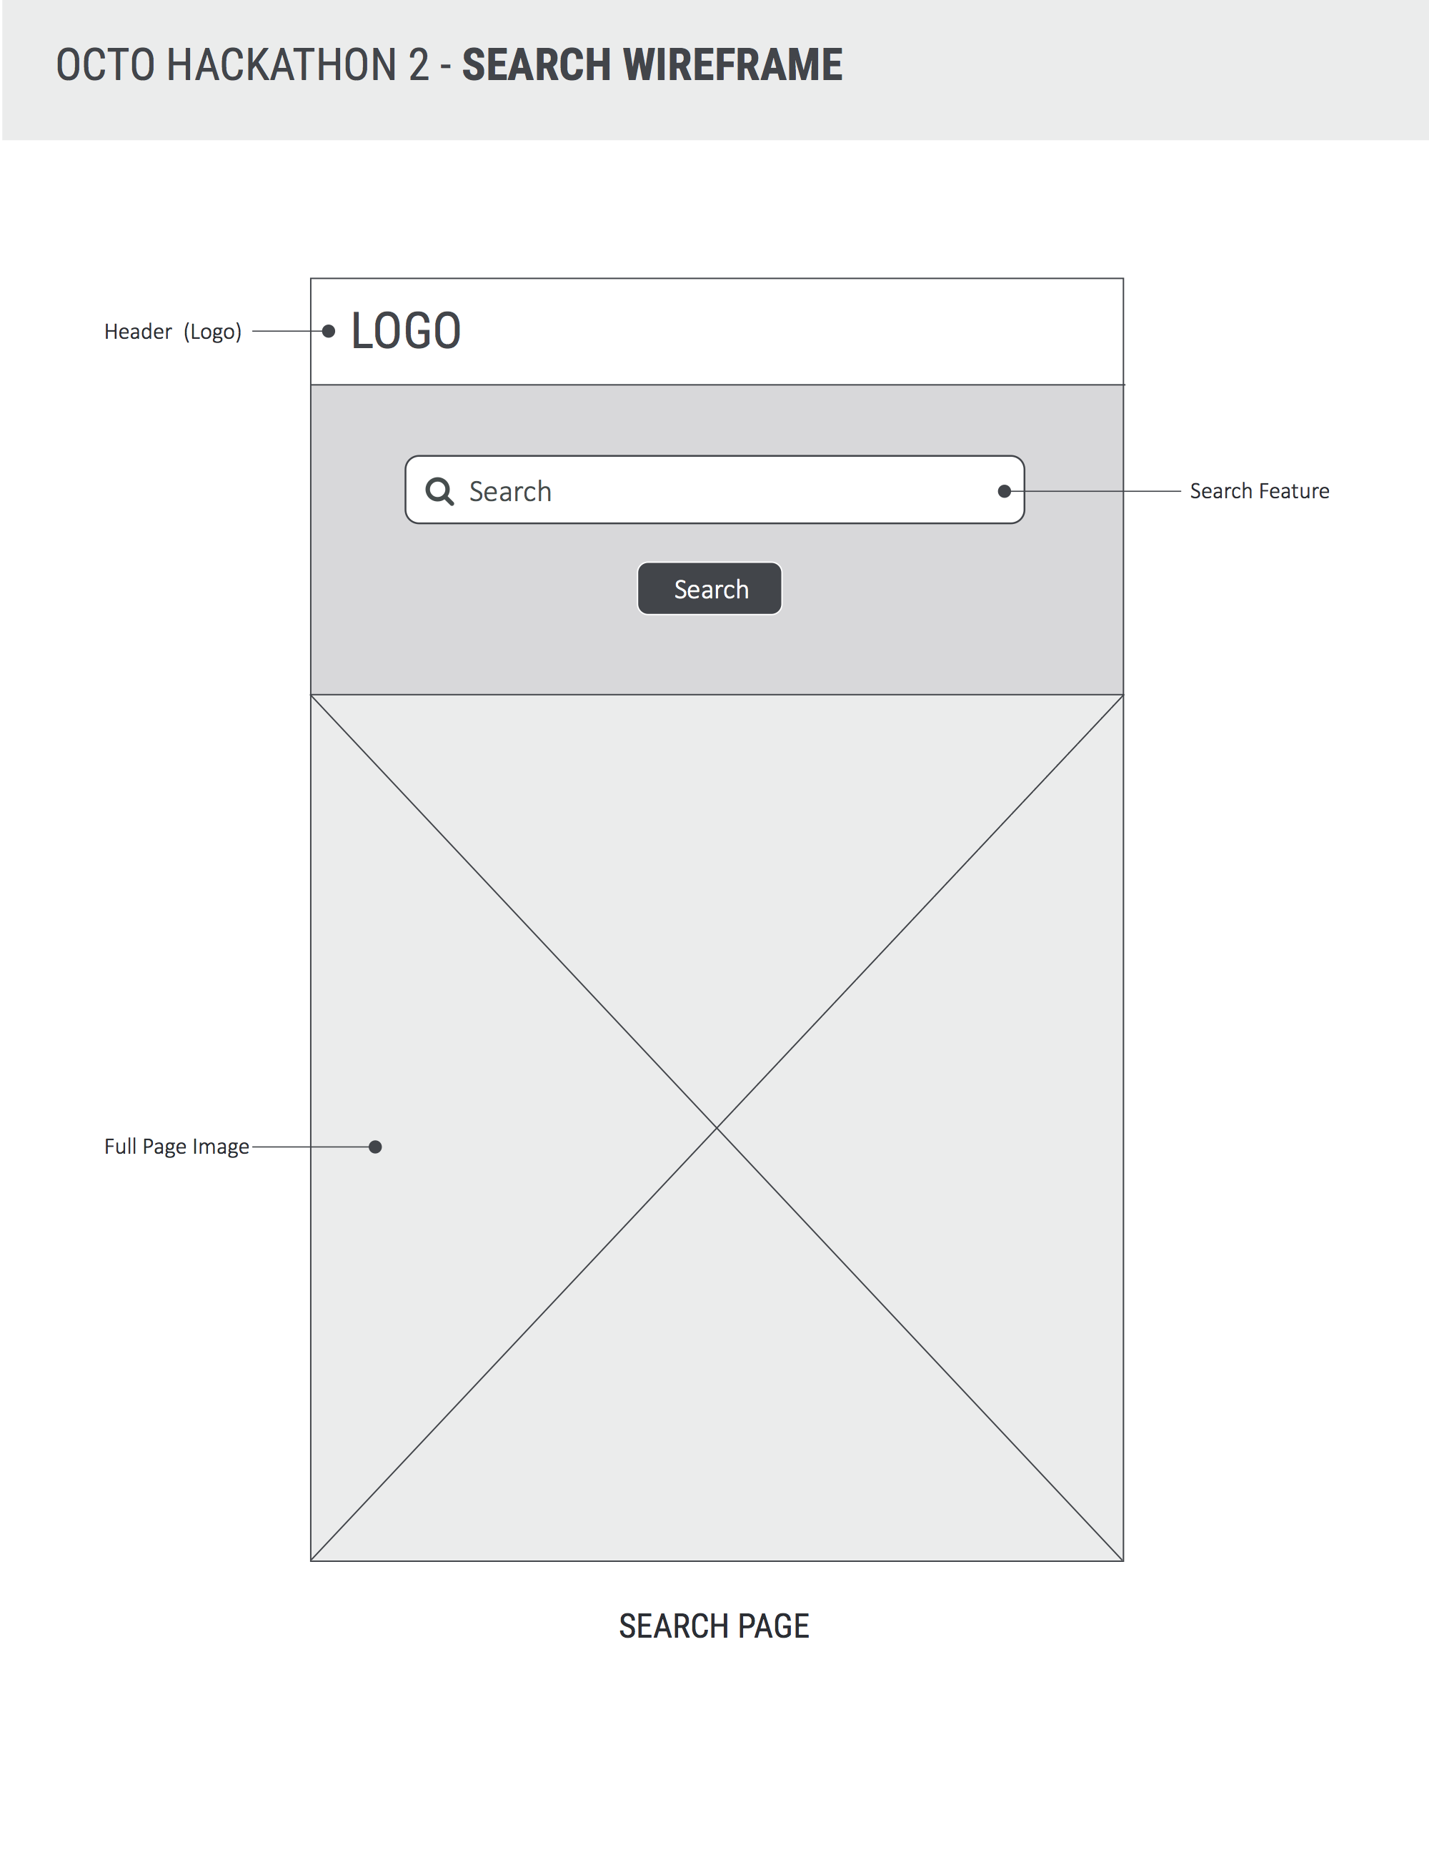

**INFLO Dashboard Screen (Wireframe):**

* Logo centered at top (alt text for logo image; link back to home page)
* Search centered under logo (alt text for search button if image used)
* Search includes example input “Fairfax, VA”
* Focus is on search on page load
* Tagline below search box
  + “How much do you now about where you live?”
* County name and associated state is shown under search.
  + County name is larger than state showing data is pertaining to county only.
  + Large score is shown on right with percentage.
* Four tiles are displayed below county name and score
  + “People”, “Travel Safety”, “Air Quality”, “Water Quality”

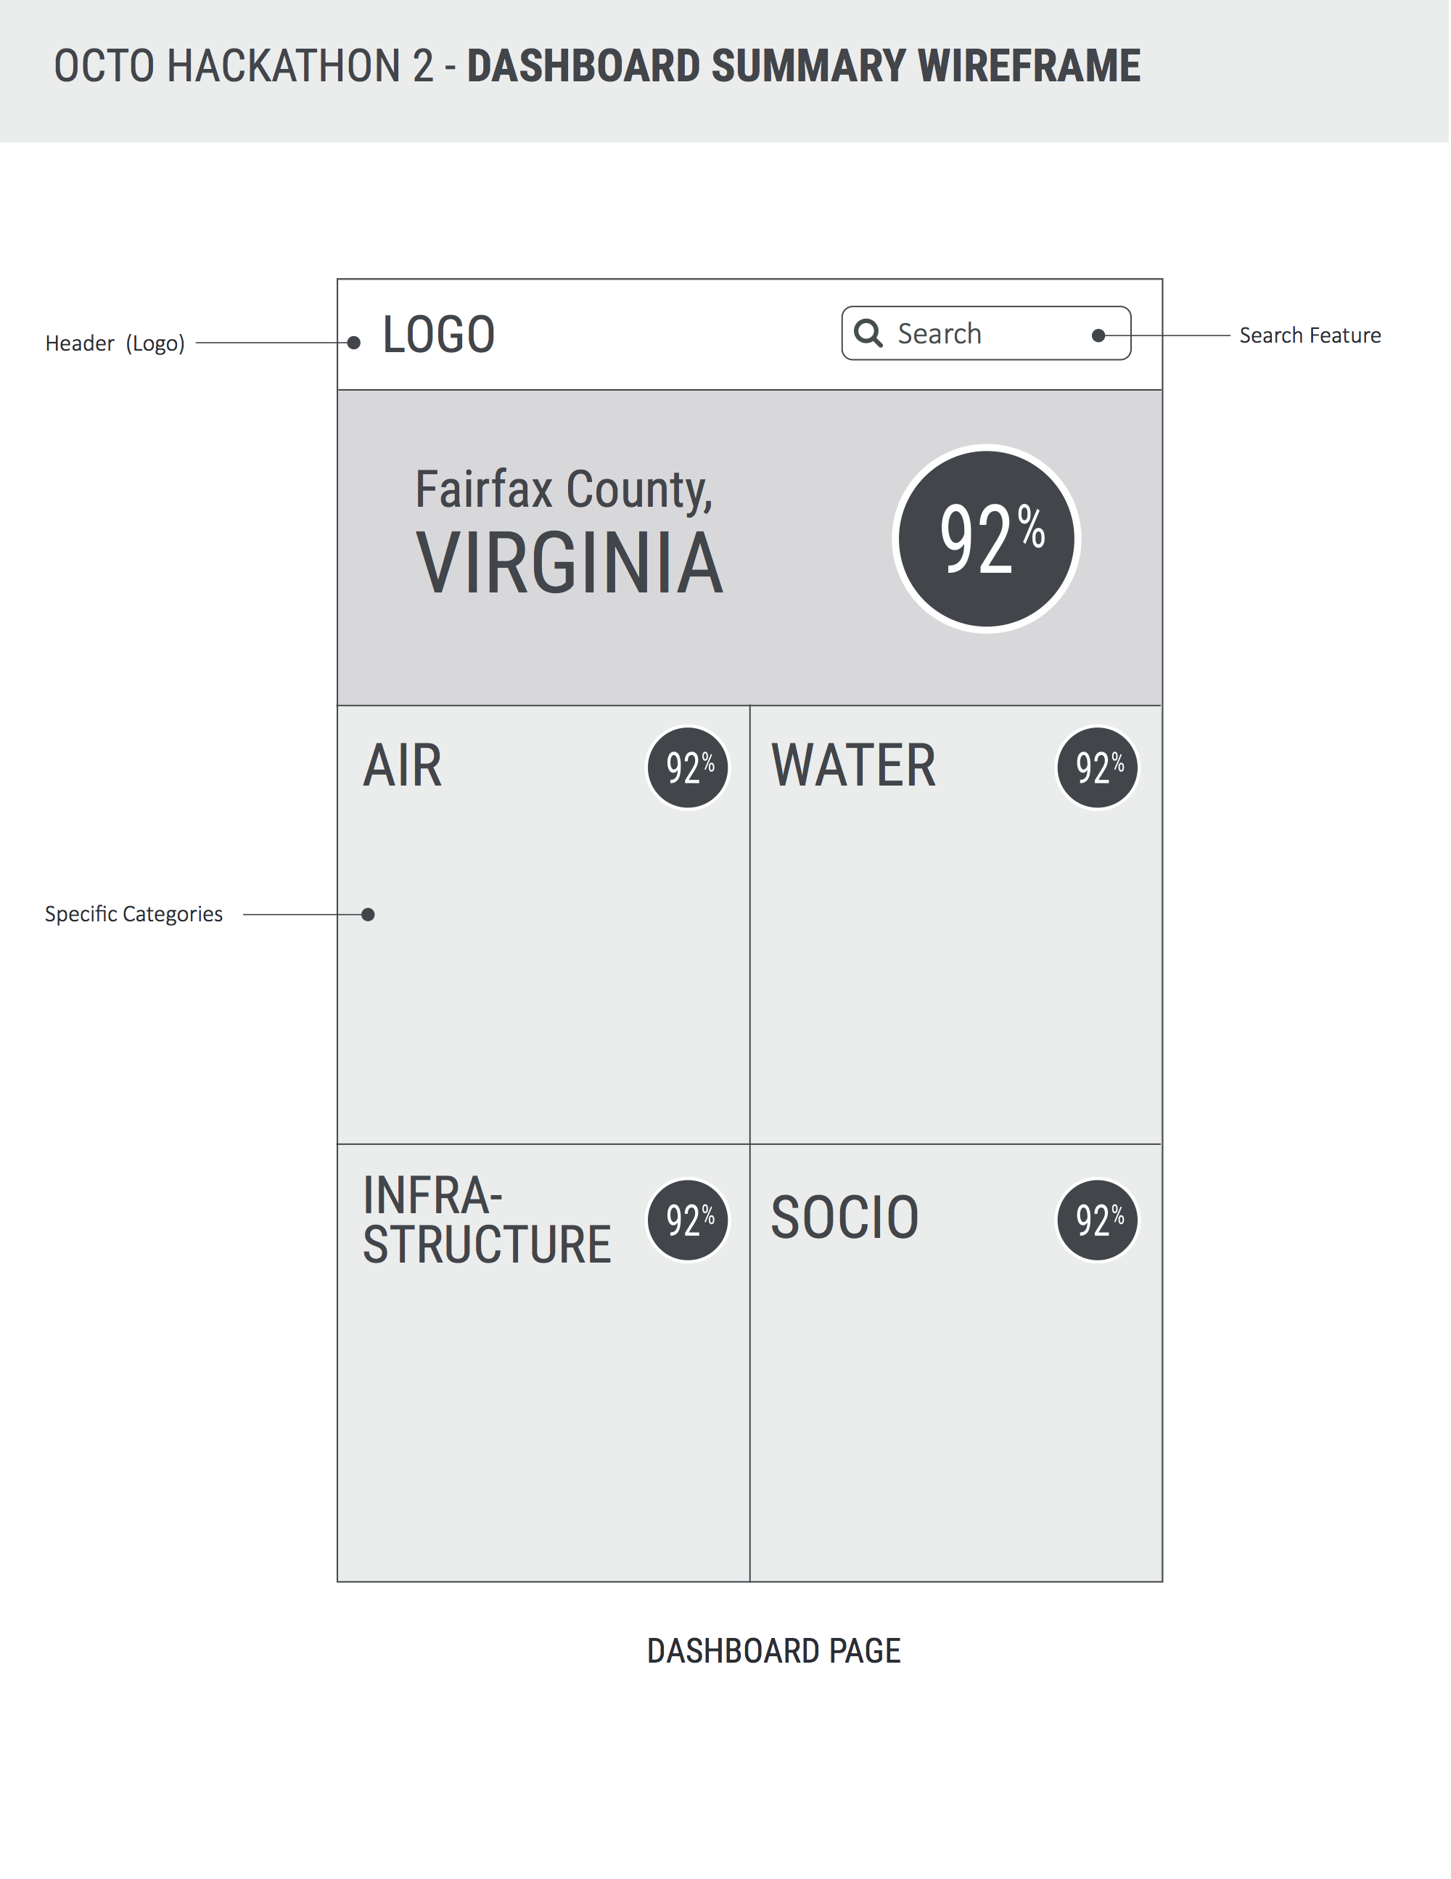**INFLO Tiles (Wireframe):**

* “People”, “Travel Safety”, “Air Quality”, “Water Quality”
  + People
    - Median Income
    - Percentage of Unemployed
    - Rate of Violent Crime
  + Travel Safety
    - Highway Roads
    - Streets
    - Traffic Fatality
  + Air Quality
    - Nitrogen Dioxide (NO2)
    - Sulfur Dioxide (SO2)
    - Carbon Monoxide (NO2)
  + Water Quality
    - Percentage of county drought
    - Percentage of Mercury
    - Percentage of Arsenic
* *Show more info about data point on select?*
* *Small text “Levels based on blab bla bla Data source”?*

Any percentage under 50% will display as the difference from the mean.

30% Higher = 70% Lower

**Conclusion**

A simple and informative search is necessary for an effective user experience. Clear direction and understandable terminology is needed. Accessibility should always be considered to allow for a diverse base of users.

Data should be presented in a way that is obvious to the user. All data points should relate to the county searched as well as its place relative to the larger data set.

**UX Testing Approach**

**UX Testing Overview**

Octo User Experience Architects design and conduct multi-faceted usability tests with the goal of informing product design and eliminating usability problems and frustrations during agile development cycles. Findings of usability testing can serve as benchmarks against which to judge the usability of future versions of digital products.

**Be Specific with Test Objectives**

Test objectives must be specific: “We want to see if the product is easy to use” is too general. To formulate test objectives, think about:

* Aspects of the product that are of concern
* Tasks that might be difficult
* Groups of users which may encounter difficulties
* Feedback from users
* Concerns of the product owners
* Problems raised by designers/developers

Untested concerns or assumptions regarding users and product usage held by the designers/developers

**Developing Test Scenarios**

The user must be able to define a discernable path to complete common and critical functionality. The interface should be designed to provide environmental support to the user’s efforts. This means that the interface should help facilitate task performance and to minimize hindrances, distractions, and potential errors.

**Factors contributing to this dimension include:**

* Enabling users to achieve goals and perform tasks
* Sequential Clarity
* Simplicity
* User Focus
* Accommodation
* Traceability
* Forgiveness/Recoverability
* User Control

**Determining UX Focus Points**

Any interactive sequence must be viewed within a larger framework. Users’ prior experience, history of interactions with the system, and awareness of their “location” within the system all contribute to the quality of the user experience.

**Factors contributing to the dimension of Context and Relations include:**

* Predictability
* Consistency
* Familiarity
* Expertise and Training
* Situational Awareness
* Responsiveness

**Determining UX Focus Points**

Any interactive sequence must be viewed within a larger framework. Users’ prior experience, history of interactions with the system, and awareness of their “location” within the system all contribute to the quality of the user experience.

**Factors contributing to the dimension of Context and Relations include:**

* Predictability
* Consistency
* Familiarity
* Expertise and Training
* Situational Awareness
* Responsiveness,
* Interpretation
* Precision

**Developing Test Scenarios**

The user must be able to define a discernable path to complete common and critical functionality. The interface should be designed to provide environmental support to the user’s efforts. This means that the interface should help facilitate task performance and to minimize hindrances, distractions, and potential errors.

**Factors contributing to this dimension include:**

* Enabling users to achieve goals and perform tasks
* Sequential Clarity
* Simplicity
* User Focus
* Accommodation
* Traceability
* Forgiveness/Recoverability
* User Control

**Recruiting Participants**

If you want a representative cross-section of users, recruit from every “touch-point” possible. This includes target user group, SMEs, and users with diverse skill sets. Consider a variety of participants drawn from a range of user personas who fit into the overall user group to provide full coverage of the range of interactions that the user base might display.

**The Test**

**Drafting and Refining Tests**

Set tasks that are essential to product success, the product was built/designed for a reason - can the target audience do what they’re supposed to do?

It's also a good idea to ask the resource users to suggest tasks during the interview sessions. While this gives another indication of their expectations and requirements, it may suggest new functionality or priorities.

People tend to perform more naturally if you provide them with scenarios rather than instructions. When giving tasks, use phrases like ‘Scenario A has occurred, and you need to update you manager with the current intelligence reports on A - find the Latest Intelligence Reports on A.”

Only give participants one task at a time. More than one may confuse them, or alter their approach to the test and skew the data being collected.

If the participant is required to use inputs from outside the test (e.g. an externally issued password to the product), give the participant those inputs in the format they will be presented. This will provide useful feedback on all elements of the process, rather than just the product itself.

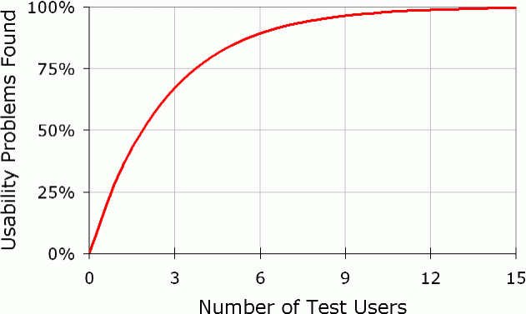

**Testing Sessions**

**5+5+5 Testing**

OCG uses a 5x5x5 format to conduct user testing, in which 5 users completed testing on the initial design iteration, with 5 users testing each subsequent design iteration that incorporates revisions from previous testing. This format of usability testing is an industry best practice, which reveals the vast majority of potential usability issues, while enabling organizations to conduct testing with limited user pools.

**Team of UX Analysts**

Try to operate as a team with multiple analysts when conducting UX testing. This method gives the best opportunity to collect usable data as each member is focused on their specific task(s) and can devote their complete attention to the actions and feedback of the participant as related to their specific areas.

**Documenting and Tracking Actions**

Usability testing enables the gathering of information from people who use a product. For best results, you want to use participants who have never seen the product before – and ask them to perform a series of tasks. It is critical not to tell the users how to perform the specific tasks because you want to observe them, take notes, and get their feedback.

**Collecting Feedback**

Comments from participants actively using the product can give an incredible depth of information on the product. Constructive user feedback can be obtained individually or from a group of users. When working with individuals, being able to see the users’ body language and facial expressions gives you as much or more information than knowing if they completed the tasks successfully. Were they frustrated? Did they seem confused? Were they comfortable moving from one screen to the next while using the product?

Ask participants to share what they are thinking out loud. Learning their thought process as they work to complete a task gives insight on ways to make that task simpler or more streamlined.

**Addressing Testing Data during the Testing Process**

Analyze data and feedback for any significant issues that may skew the test. Recommend changes and/or solutions before the next round of testing is conducted. Review all changes, when completed, before next testing session.

**In-Process Change Recommendations**

Summarize the data analysis and offer recommendations and solutions as drawn from the latest testing data throughout the development cycle. Include industry best practices as guidelines when possible. Ensure that these changes are implemented into the next iteration of the product to allow for both incremental development and measurement of improvement or detriment of newly added interface or product features

**UX Testing Process**

